005-0021
Outsourcing: Benefits and Risks Assessment for Enterprises

Yan Zhang
AiMeS Centre, the University of Liverpool Management School
10 Duke Street, Liverpool, UK, L1 5AS
e-mail: zhy@liverpool.ac.uk

Abstract
The globalisation of manufacturing has become a major issue for manufacturers, especially in the UK and US. Outsourcing reduces huge production costs for OEMs, however, the potential risks generated by the networked production lines make organisations unable to execute from a strategic perspective. However, networking in the global scale raises negative issues, such as job security and industry shrink, as well as limited property right transfer and competitiveness, supply chain control and independence. The paper attempts to provide the methodology of decision-making option by analysing and examining the benefits, risks and decision criteria for manufacturing enterprises. Also illustrate an insight that enterprise should take full consideration of related factors from its own individual stand.

Keywords
Outsourcing, Networked Manufacturing, Globalisation, Decision Support

- Introduction
Increasing pressures due to market globalisation, lean enterprises and technological breakthroughs have stimulated independent firms to collaborate in a supply chain in order to gain mutual benefits. Networked manufacturing among independent enterprises is vital to attain the flexibility necessary to enable them to progressively improve manufacturing processes in response to rapidly changing market conditions. Over the last number of years, outsourcing has become a strategic approach to reducing supply chain costs in the value chain. The trend toward outsourcing manufacturing is well-established and apparently accelerating. The result of a survey (Corbett, 2004) to the delegates of the 2004 Outsourcing World Summit indicated that 25% of the budget is outsourced then, further more, the average would be 34% 18 months from then on, which presents the voice from different cross section of enterprise types and sizes around the world.

Outsourcing is all about transforming business operations by bringing in the best to help make an organisation even better (Corbett, 2002). Most of the observed outsourcing activities appear to be straightforward examples of firms seeking to lower costs by contracting with suppliers who enjoy lower factor costs, such as labor, and suppliers who enjoy economies of scale (Grahovac and Geoffrey, 2003). However, cost deduction is neither all the outsourcing process, nor the impetus and motivation to manufacturers. This paper aims to deliver the main factors regarding the benefits and risks for an outsourcing or in-house decision-making, so as to outline a general parameters diagram for the enterprises. In the following section, theoretical discussion on the benefits and risk assessment of outsourcing from a “core competence” perspective is presented, involved with the outline of the decision formulation steps from the initial stage. Finally, the proposed advice of an effective decision is reviewed for entrepreneurs.
- Literature Review: cost saving vs core competence

The growth in outsourcing over the last two decades has been unprecedented. Lee et al (2000) summerised key distinctions among major theories as illustrated in Table 1.

Orientation | Theory | Focus | Resource | Main constructs
Strategic  Management  View | Resource  Based | Internal slack  resource | Physical capital,  Human capital,  Organizational capital | 1. Value  2. Rareness  3. Imperfect, immutability, Strategic  4. Non-substitutability
Strategic  Management  View | Resource  Dependence | External  resource  (Uncertainty) | Land,  Labor,  Capital, Information,  Products(service) | 1. Task dimensions (Concentration, Munificence, Interconnectedness)  2. Resource dimensions (Importance, Discretion, Alternatives)
Economic  View | Transaction  Cost | Cost-efficiency (Economics of scale) | Production cost,  Transaction cost | 1. Asset specificity,  2. Uncertainty, Economic  3. Infrequency
Economic  View | Agency Cost | Principal-agent  relationship  (Contracts) | Monitoring cost,  Bonding cost,  Residual loss cost | 1. Uncertainty,  2. Risk aversion,  3. Programmability  4. Measurability,  5. Length of relationship
Table 1. Key distinctions among major theories used in outsourcing research
Source: Lee et al (2000)

A recent study published in Oct 2005 by LogicaCMG, an Anglo-Dutch outsourcing firm, says that the shares of British quoted firms, after announcing outsourcing deals, outperformed comparable firms without such a deal by an average of 1.7% in the month after the announcement. LogicaCMG states if British firms increase their outsourcing by half by the end of the decade, an extra £10 billion will be added to their stockmarket value (The Economist, 2005). A major influence impacting on the outsourcing of products is consideration of scale and costs (Finlay and King, 1999). Outsourcing's popularity derives largely from the huge cost savings it can bring and the value it can create. Jennings (1997) and Quinn and Hilmer (1994) identify issues including costs and supplier relationships which should be considered in the outsourcing decision without proposing a framework that would guide a company in the process.

Possibly due to the cost-saving effect, there is significant number of literatures addressing the cost-effect of outsourcing. The tendency of firms to locate their productive processes in places where production factors are cheaper becomes evident in what has come to be known as “global outsourcing” (Heecks et al., 2001; Zhaohui Zeng, 2000). Direct benefits are obtained where outsource companies provide the same or better service for the same or less cost than could be achieved in internal process by the company (Juma’h and Wood, 2000). Beaumont and Sohal (2004) advocate that dealing in imperfect markets involves costs (such as identifying appropriate vendors and verifying their competence, communicating changing requirements to them, providing feedback and monitoring their performances) and risks (of vendors going out of business or being unable to meet specifications), deciding whether to insource or outsource depends on the relative long-term costs.

However, since many decisions on outsourcing are motivated by cost consideration, the effects on the company’s competence are still mainly an open question. Cost-cutting or core competence, is the original precondition for an outsourcing decision? Which one is impetus, competence results into outsourcing, or outsourcing leads to competence? If enterprises follow the competence-oriented methodology, what is the basic step for the decision formulation?

Three examples of definitions for core competence presented are quoted:
  - The collective learning in the organisation, especially how to co-ordinate diverse production skills and integrated multiple streams of technologies (Hamel and Prahalad, 1990).
  - Intangible or the bundling of intangible assets, which cannot be easily duplicated to competitors; however they also would be difficult to replace if a company found them destroyed or damaged (Whitehall, 1997).
  - A unique combination of technologies, knowledge and skills that are possessed by one company in the market. A core competence is usually the basis for a whole variety of end products and services, both now and in the future. Core competence has various attributes such as complexity, invisibility, inimitability, durability, appropriability and non-substitutability (Petts, 1997).

Arnold (2000) describes manufacturing as a non-differentiating activity that easily could be transferred and handled by other companies. The core competencies are product design, logistics and sourcing and marketing. Arnold also defines four levels of outsourcing: traditional buying, modular sourcing, in-house plants and the “de-materialised” company. The desired level, according to his opinion, is the de-materialised company, which means that suppliers are responsible not only for different functions, but also the co-ordination between the suppliers.

Core competence lies in an ability to differentiate outputs so that the manufacturers could match the customer service precisely. Achieving core competency concentration concerns long-term survival and further development as much as adding value. Quinn (1999) argues that once a company develops true best-in-class world core competencies, it should ring fence and thus defend such essential areas and activities. Honda, for example, does not outsource the design and manufacture of key equipment in order to protect its core competence, the design and manufacture of clean, efficient, small engines. Hence, what is core and what are the “best ways” to structure outsourcing remains a critical debate. Another influential article by Hamel and Prahalad (1990) on corporate core competence is often used as a general justification: outsourcing can provide a shortcut to more competitive products, instead of simply cutting cost. Prahalad and Hamel (1990) also argue that the real sources of competitive advantage are to be found in management's ability to consolidate corporate-wide technologies and production skills into competencies that empower individual businesses to adapt rapidly to changing business opportunities.

Competencies are the skills, knowledge and technologies that an organisation possesses on which its success depends. Although an organisation will need to reach a threshold level of competence in all activities that it undertakes, it is likely that only some of these activities are core competencies (Johnson and Scholes, 1999). Enterprises outsource the ability, which they are not unique on but other suppliers do, so that they could focus on their own strength and further consolidate. Therefore, core competence is the driving force behind outsourcing decision. These core competencies underpin the ability of the organisation to outperform the competition and therefore must be defended and nurtured.

- Outsourcing Decision Principle: Benefits and Risk
Outsourcing offers several advantages, such as enabling existing staff to concentrate on core activities on organisational specialisations, focusing on achieving key strategic objectives, lowering or stabilising overhead costs, and thereby gaining cost advantage over the competition, providing flexibility in response to changing market conditions, and reducing investment in high technology (Kliem, 1999; Quinn 1999). Crucially, outsourcing can provide companies with greater capacity for flexibility, especially in the purchase of rapidly developing new technologies, fashion goods, or the myriad components of complex systems (Carlson, 1989; Harrison, 1994). On the other hand, outsourcing is regarded as a two-way street, requiring the understanding the rewards and according risks. These include becoming dependent on outside suppliers for services, failing to realise the purported hidden cost savings to outsourcing, losing control over critical functions, having to face the prospect of managing relationships that go wrong and lowering the morale of permanent employees (Currie and Willcocks, 1997; Kliem, 1999). As outsourcing leads to a re-definition of organisational boundaries and structural adjustments involving human resources, these changes incur social as well as financial costs.

Table 2 below shows the brief pro and con of outsourcing for enterprises.
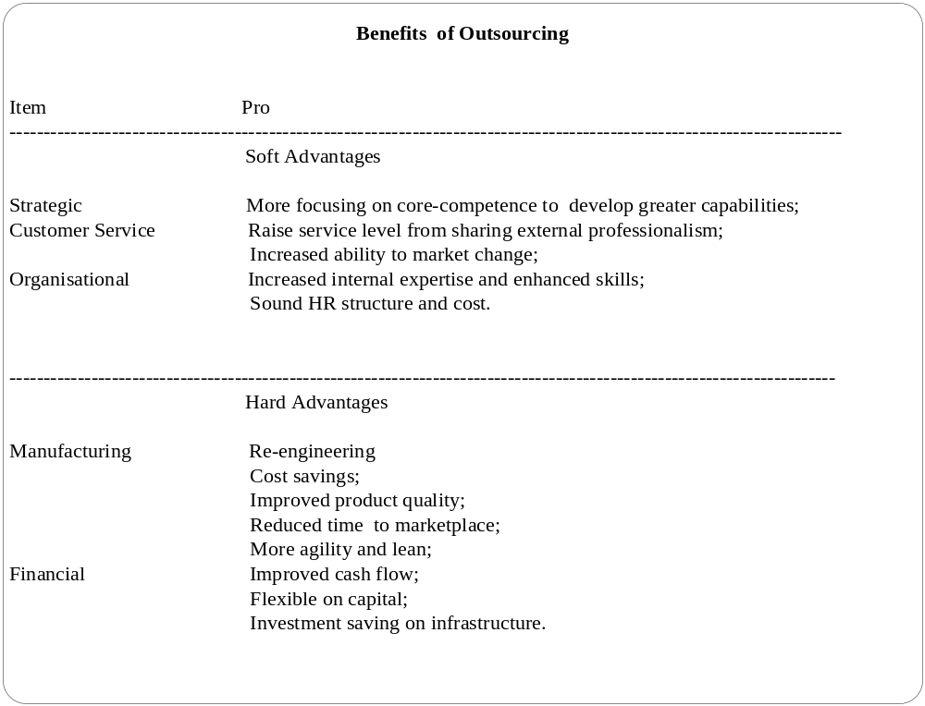
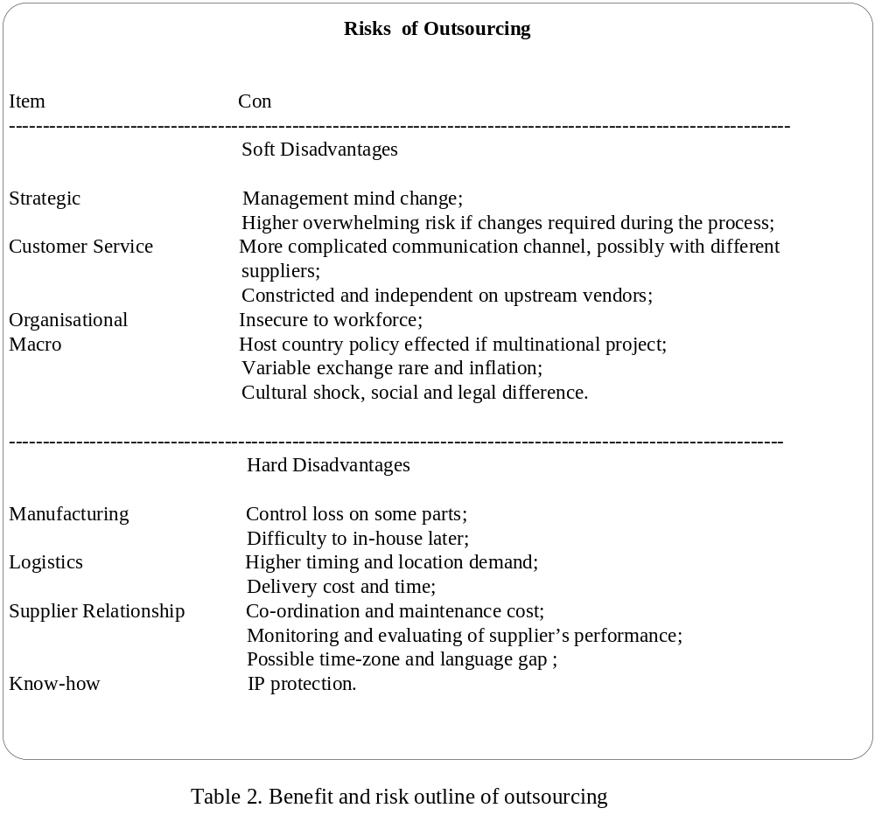

- Decision-making Framework
Starting from a strategic perspective following an executive outline and time order, a disciplined outsourcing lifecycle methodology is needed for an outsourcing decision. Initially, the typical questions involved to be considered in the context of enterprise's situation include:

  - What is the core competence of the defined enterprise? Assess proactively and objectively.
  - Make more detailed division and segment for internal operation batch and cooperative functionality, then which part distributes less compared with the input? How vital is manufacturing itself counting in the business scope?
  - Is the outsourcing strategy realistic and executable for a particular enterprise? -- Especially for SMEs. What is the external situation in a national/international scale as for the weak line of the above assessment and the industrial overview?
  - Does the sub-contracting methodology reflect the mutual interests of both the downstream clients and OEMs? Are there clear objective metrics and deliverables for the definition of service level expected?
  - Does outsourcing enable to provide the latest and advanced technology and expertise?
  - Is there any mature ability both in human resource and management for the project?
  - How is the ability of coordinating with the supplier and evaluating performance? Is there any documented governance plan, contingency and dispute resolution process?
  - Have the documented intellectual property data security and possible license transfer been identified?
  - How is the climate for outsourcing and transferring policy?

The outsourcing model consists of four major elements (see Figure 1): Outsourcing subject, outsourcing object, outsourcing partner, and outsourcing design. From an industrial perspective, the outsourcing object is closely linked with the degree of manufacturing penetration. The decision-maker level may push the outsourcing team to rush through the requirements, supplier selection and contract phases of the lifecycle. These steps are the foundation of the outsourcing initiative, however, the creation, review and approval of these steps admittedly requires a huge commitment of employee resources, time and financial input, but rushing through them may result in conflicts in the governance phase where the enterprise may be at the greatest risk from a financial and competitiveness point view. In anticipation of reaping the benefits of outsourcing, the central thinking behind the decision is: the current process is to strengthen or to weaken the existing core competence.

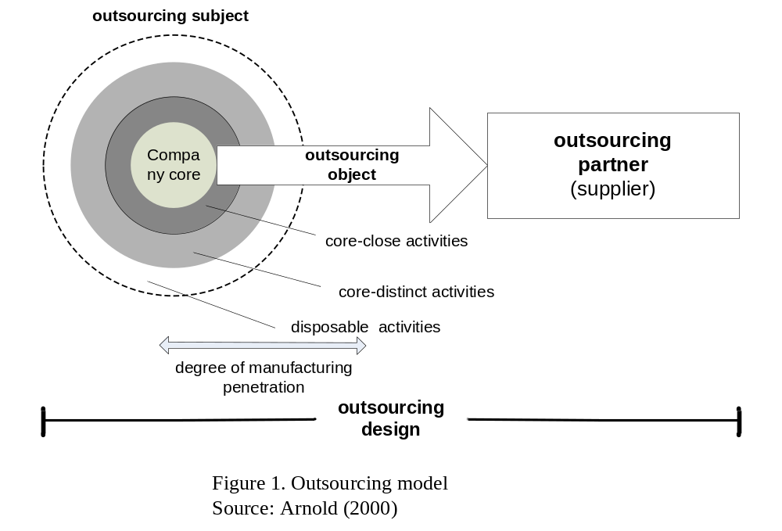

To avoid the risks and redundancy, enterprises should be able to protect its interests from decision-making stage, by devising and implementing a model that would show and compare the variables into the equation, so that the core competence is guaranteed to highlight, rather than jumping into a bandwagon. As a summary, the main steps and framework are illustrated in the Figure 2.
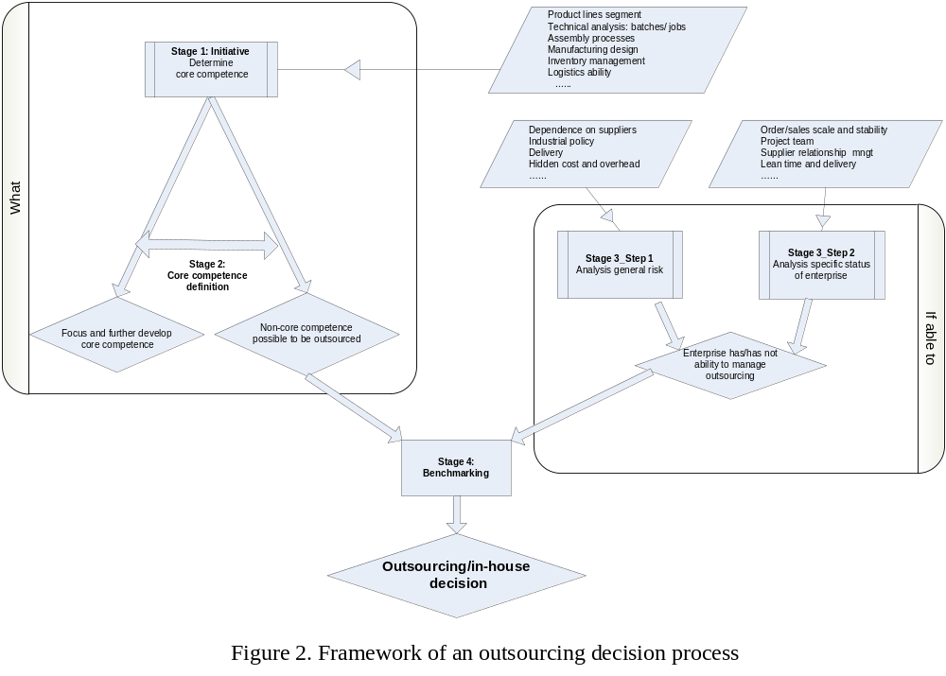
Stage 1: To determine what is the internal core competence within the enterprise;
Stage 2: To define if any non core competence to be outsourced;
Meanwhile;
Stage 3: To assess risk, both macro and micro;
Finally,
Stage 4: To conclude if outsourcing project controllable under the current capability compared with expectation

The outsourcing framework consists of a number of logically sequential steps. This is an if-scenario based thinking, namely, if anything currently appropriate for enterprises to outsource, and then, if the enterprises have the management ability. All the processes start from the practice of enterprises, instead of following the external wave and fad.

5. Conclusion
Creating awareness among enterprises on the results of outsourcing is a key element for achieving full benefits from outsourcing activities and promoting collaboration across nations. Cox (1996) insisted that the outsourcing decision involves understanding asset specificity that is embedded in an entrepreneurial rather than a productive view of the firm. Outsourcing is a powerful business strategy that requires a paradigm shift in the way global business is conducted. The outsourcing framework proposes a four-stage analysis to assist enterprises in the formulation of an effective outsourcing decision. The purpose is to alert basic point issues, along with a comprehensive factor analysis, that should be considered if an effective outsourcing decision is to be formulated. This research has focused on a number of industry settings to enable a comparison to be made of how different business individual conditions impact on outsourcing decisions. More consideration and comparison should be taken from related internal factors of enterprises’ own individual stand. It is fairly important for organisations embarking on outsourcing initiative understand that success depends on a disciplined lifecycle methodology, which requires a commitment of define, refine and assess the core competence correctly and precisely. It also relies on support from cross-functional team with a clear understanding of the enterprise’s strategy and operational model. It is imperative that entrepreneurs need to increase understanding of core competencies, as well as what is in real need and the internal capability to manage. The systematic decision-making on outsourcing is due to based on a strategic, tactical and operational level, and is regarded as a fundamental business change. All the decision is defined on the internal capability evaluation, initially with core competence configuration, which serves as a starting point for mapping alternative processes.

- References

Arnold, U. (2000), “New dimensions of outsourcing: a combination of transaction cost economics and the core competencies concept”. European Journal of Purchasing & Supply Management, Vol. 6, 23-29.

Beaumont, N and Soha, A. (2004), “Outsourcing in Australia”, International Journal of Operations & Production Management, Vol. 24 NO. 7, 2004 pp. 688-700.

Carlson, B. (1989), “Flexibility and theory of the firm”, International Journal of Industrial Organization, Vol. 7 No. 1, pp. 179-203.

Corbett, M. (2002), “The 2002 Strategic Outsourcing Study” Published by Michael F. Corbett & Associates, Ltd.

Corbett (2004), “Leading Outsourcing Indicators 2004”, The 2004 Outsourcing World Summit, February 23rd-25th 2004 US

Cox, A.W. (1996), “Relational competence and strategic procurement management: towards an entrepreneurial and contractual theory of the firm”, European Journal of Purchasing and Supply Management, Vol. 2 No. 1, pp. 57-70.

Currie, W. and Willcocks, L.P. (1997), “New Strategies in IT Outsourcing: Major Trends and Global Best Practice -- Report”, Business Intelligence Ltd, London, December.

(The) Economist (2005), “Getting the measure of it”, The Economist print edition, Jun 2005.

Finlay, P.N. and King, R.M. (1999), ``IT outsourcing: a research framework'', International Journal of Technology Management, Vol. 17 No. 1-2, pp. 109-28.
Grahovac, J. and Geoffrey P., (2003), “Component Modularity, External Economies of Scale, and Outsourcing Decisions in the Supply Chain” http://www.ggparker.net/papers/SupplyChainDesign.html
Hamel, G. and Prahalad, C.K. (1990), ``The core competence of the corporation'', Harvard Business Review, May-June, pp. 71-91.

Heecks, R. (2001), “Synching or sinking? Global software outsourcing relationships”, IEEE Software, Vol. 18 No.2, pp.54-60.
Johnson, G., Scholes, K. (1999), Exploring Corporate Strategy: Text and Cases, 5th ed., Prentice-Hall, Hemel Hemstead.

Harrison, B.T. (1994), “Lean and Mean: The Changing Landscape of Corporate Power in the Age of Flexibility”, Basic Books, New York, NY.

Juma’h, A. and Wood, D. (2000), “Outsourcing implications on companies’ profitability and liquidity: a sample of UK companies”, Work Study, Vol.49 NO.7 2000 pp. 265-275.

Kliem, R.L. (1999), “Managing the risks of outsourcing agreements”, Information Systems Management, Summer, pp. 91-3.

Lee, J. N, Huynh, M.Q. and Chi-wai, K.R et al (2000), The Evolution of Outsourcing Research: What is the Next Issue? The 33rd Hawaii International Conference on System Sciences, 2000

Petts, N. (1997), “Building growth on core competences -- a practical approach”, Long Range Planning, Vol. 30 No. 4, pp. 551-61.

Quinn, J.B. (1999), "Strategic outsourcing: leveraging knowledge capabilities", Sloan Management Review, Vol. 40 No.4, pp.9-22.

Whitehall, M. (1997), “The theory and practice of competence-based competition”, Long Range Planning, Vol. 30 No. 4, pp. 615-20.

Zhaohui Zeng, A. (2000), "A synthetic study of sourcing strategies", Industrial Management & Data Systems, Vol. 100 No.5, pp.219-26.

